**Web, Mobile Design and Development**

**Group No: 5**

**CA2 part 1b**

**Jordan Davy - x00138060**

**Rachel Byrne - x00141489**

**Aoife Bergin - x00141559**

**Sketch Home/Index**

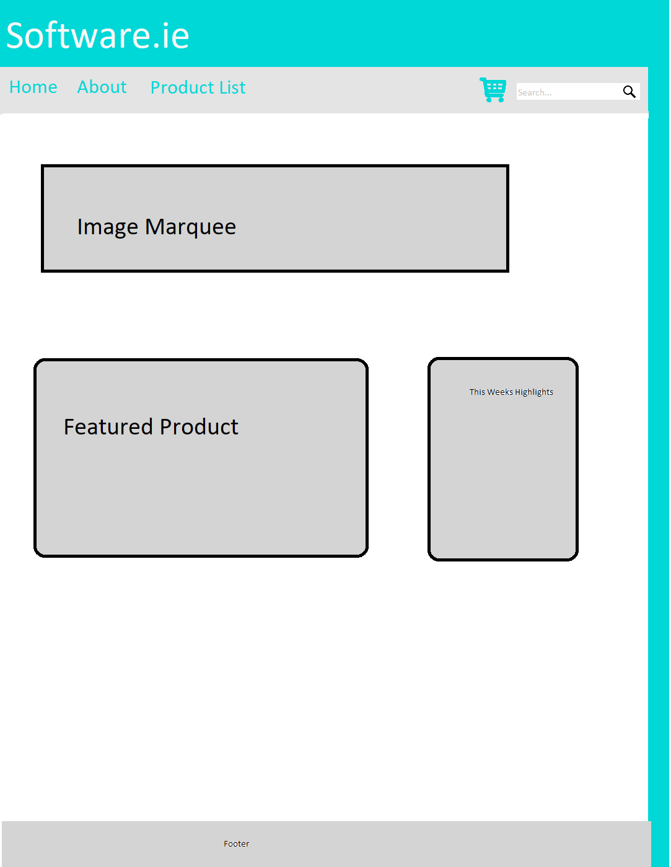

**Sketch About**

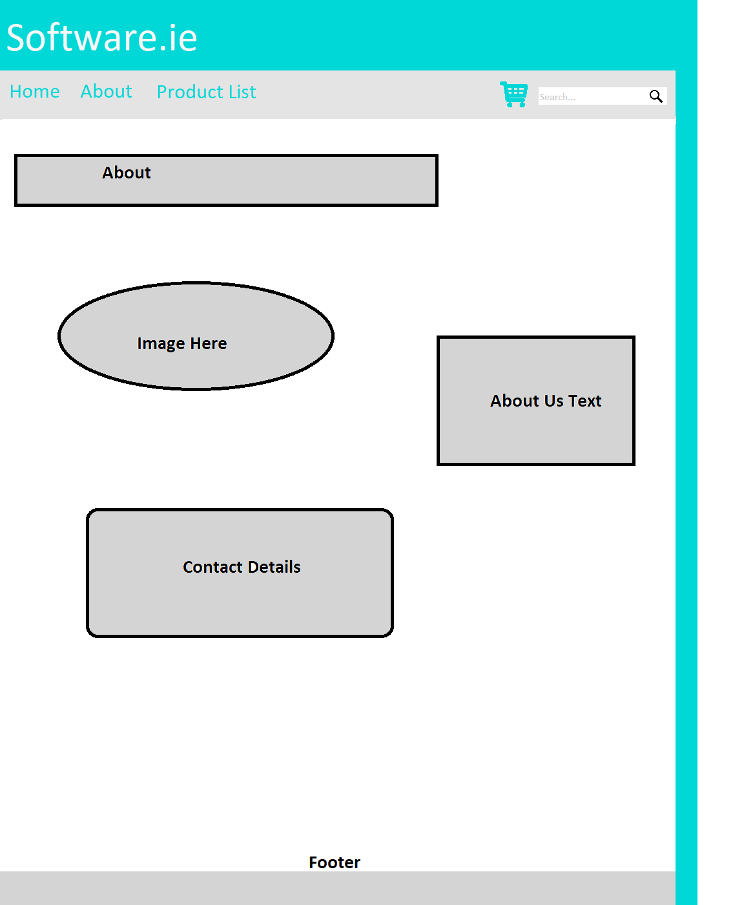

**Sketch Product**

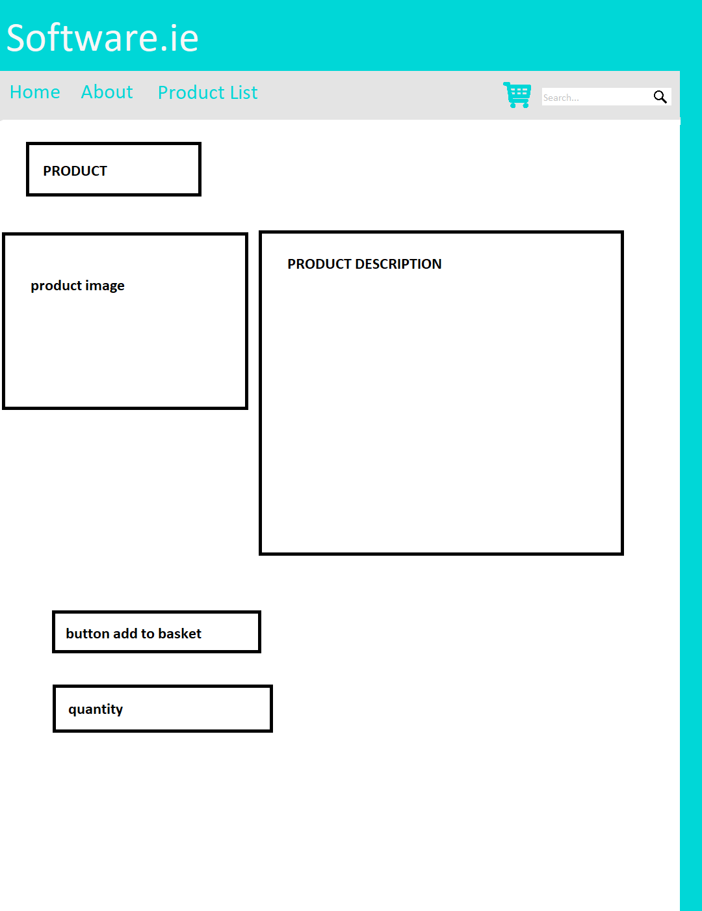

**Sketch SearchResult**

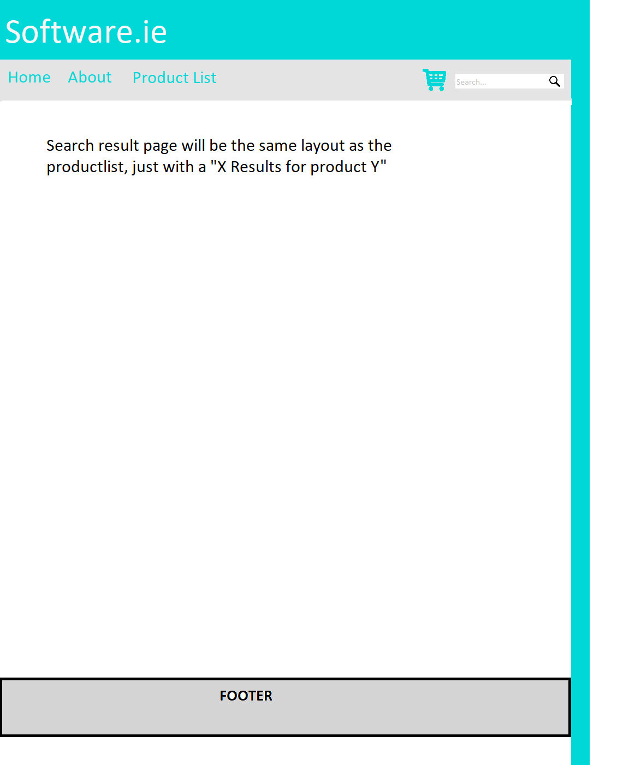

**Sketch ProductList**

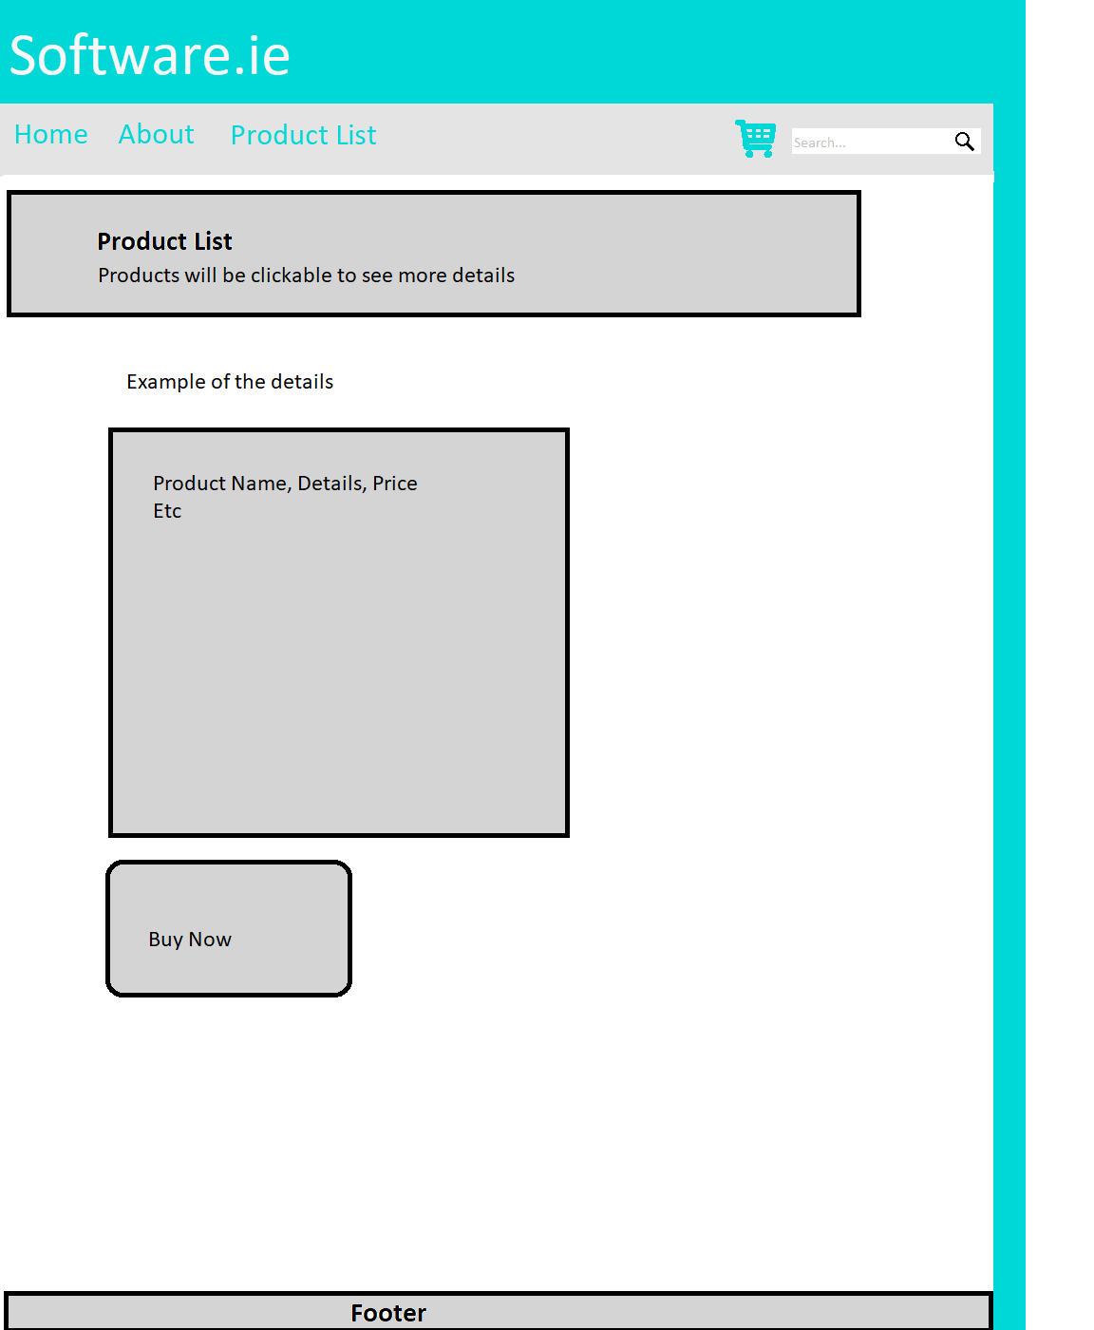

**Sketch Basket**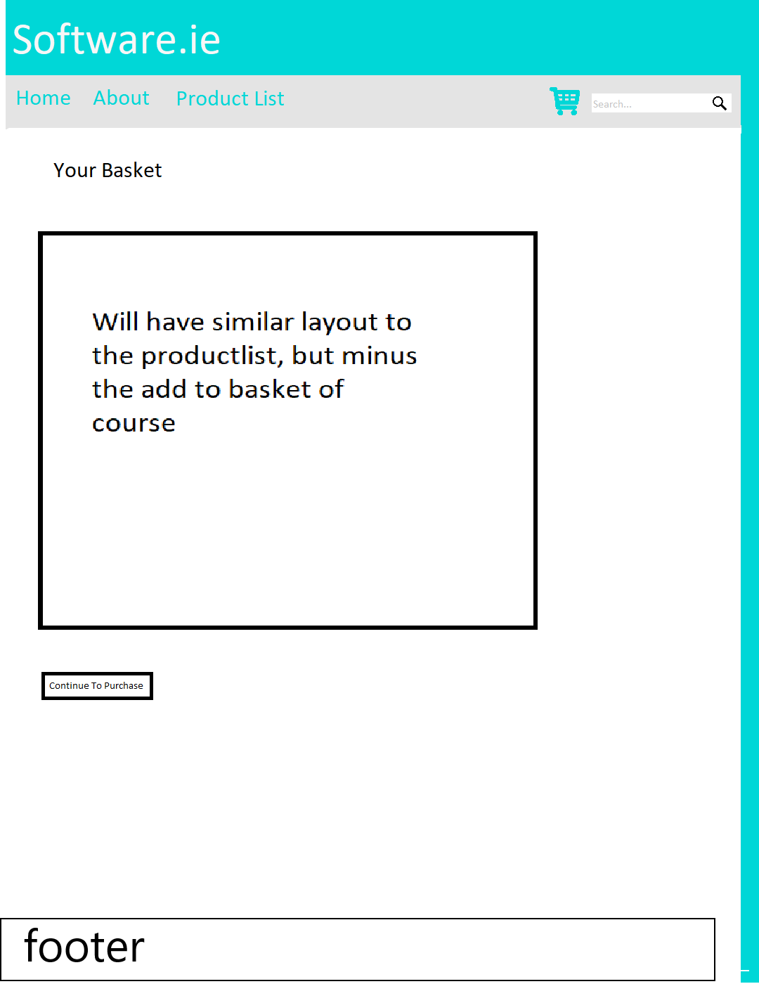

**Sketch Purchase**

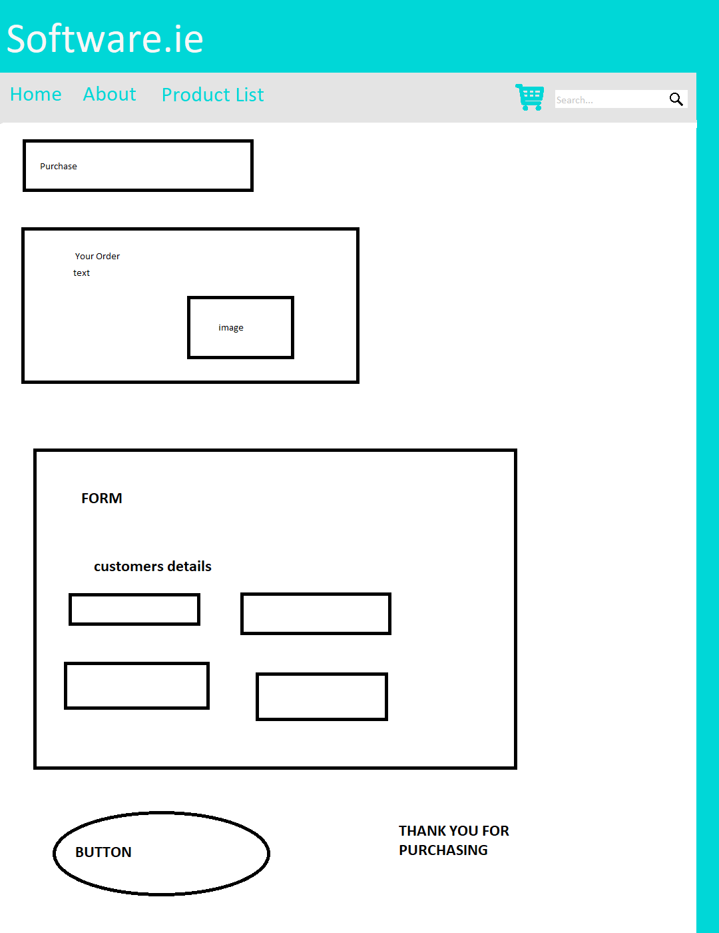

**Media content you plan to use**

**Basket Icon**

**Search Button**

**We also plan to use images for each software product such as their logo etc. but as we are unsure of our product list so at the moment we do not have the images**

**Contributions**

Jordan made the template for our sketches which includes the colour scheme. Aoife and Rachel filled in the template for each page showing where images, text and buttons may go on each page. After we had created the basis for our templates we worked through them as a group to finalize the design